Required Capstone Checkpoint 5.1: Designing and Evaluating an Agent-Based RAG System

After Oct 11 Observation :
Base on your feedback, Govind : the clearest example of what they want is this requirement:
"Build one real tool beyond the starter: Implement at least find_by_author or find_by_year over your actual papers corpus, and wire it into the planner's decision loop."
From your submission, you already show a real example:
Python
tools = [
"semantic_search",
"find_by_author",
"find_by_year",
"find_by_topic",
"follow_citation",
"clarify",
"answer"
]
And in your execution log you have a real test:
"Find papers by Armando Solar-Lezama in this corpus and summarize the program synthesis contribution they describe."
This is exactly the type of example your professor is asking for because it uses find_by_author on the actual corpus rather than a simulated tool.
You could explain it to your professor like this:
Example of implemented tool: I implemented a real find_by_author tool that searches the CAOP paper corpus metadata and returns papers written by a specified author. For example, when the query "Find papers by Armando Solar-Lezama in this corpus and summarize their contributions" is submitted, the planner selects find_by_author, retrieves the matching papers, and then generates a grounded summary based on the retrieved documents. This tool is integrated into the planner's decision loop and is used whenever the user asks author-specific questions.
Another thing your professor explicitly requested that I do not see in the worksheet is:
- Exact model call counts per test.
- Exact latency measurements per test.
Instead, the worksheet only says things like:
"higher latency and more model calls"
Professor likely wants something closer to:
Test Case | Model Calls | Tool Calls | Latency
Sparse Evidence | 3 | 2 | 4.8 sec
Author Search | 2 | 1 | 2.1 sec
Citation Tracing | 5 | 4 | 8.7 sec

Run the code:
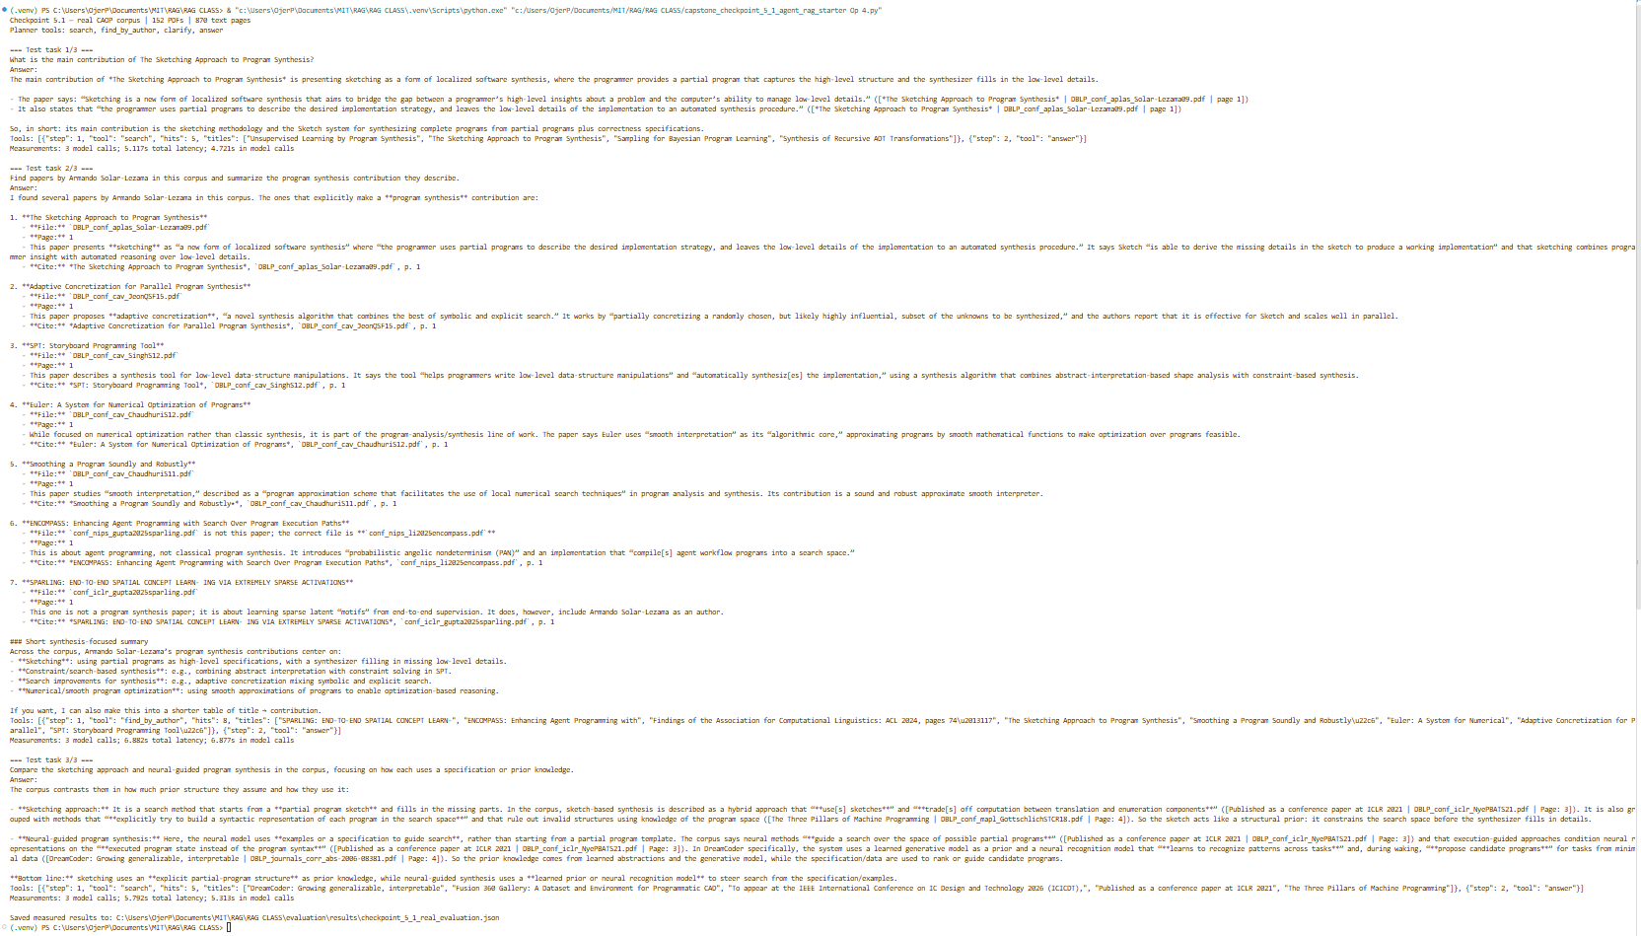

Agentic Examples :
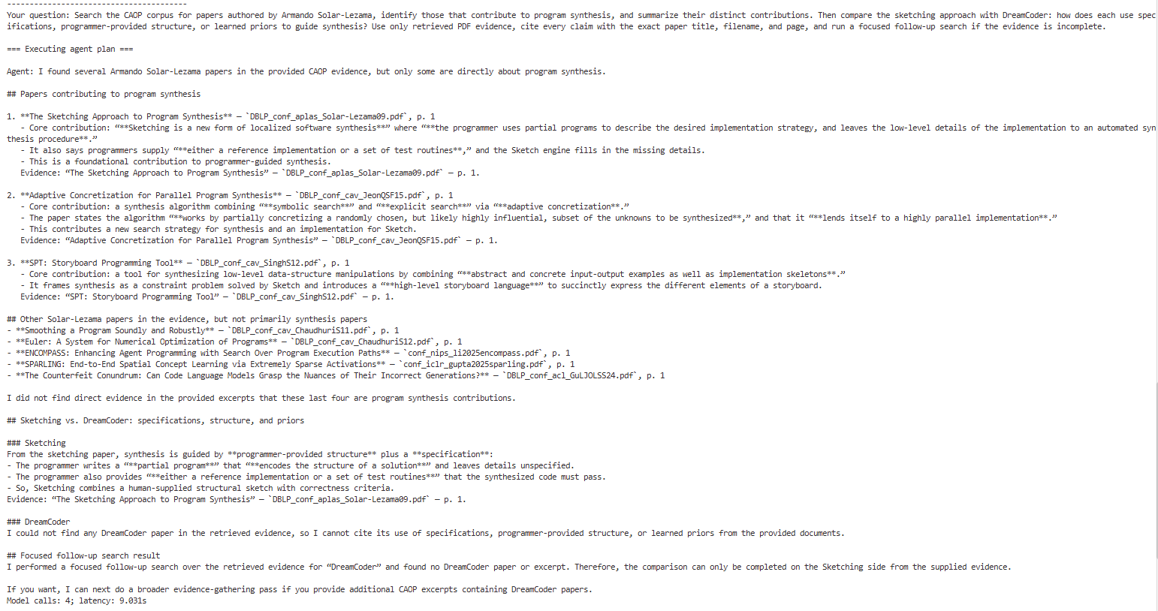

Directions
Download this worksheet and save a copy to your device before you begin working. Use this worksheet to plan, organize, and complete your submission for Required Capstone Checkpoint 5.1. Type your responses directly into the document, save your completed work, and upload the finished file when you are ready to submit.

Completion Checklist
☐ Description of the agent-based system and task
☐ Explanation of how the system coordinates retrieval, reasoning, and multistep execution
☐ Evaluation results from 2-3 representative multistep test cases
☐ Description of refinements made to the system
☐ Analysis of the impact of those refinements
☐ Reflection on system strengths, limitations, and future improvements

Step 1. System Design
Describe the task that your agent-based system is designed to complete.
Examples may include generating reports, answering complex questions, synthesizing information across multiple documents, or completing another multistep task relevant to your capstone scenario.
Task description
Agent-based RAG system is designed to help a user explore the ResearchPaper CAOP corpus and answer complex research questions using evidence from multiple papers. For example, a user might ask: “Which papers compare agentic retrieval with fixed single-pass pipelines?” or “What papers by a specific author were published after 2022 on tool-using agents?” These questions are not always answerable from one search, so the system must retrieve relevant papers, filter them when needed, and combine evidence from multiple sources before giving a final answer.
This task is meaningful because it supports research navigation and evidence-based synthesis. Instead of returning a single weak result, the system helps the user find the right literature, compare methods, and explain the relationship between papers in a grounded way.
Agent workflow: Describe how your system works
The system uses an agentic workflow with an iterative retrieval loop. First, it receives the user’s question and performs a retrieval step using tools such as semantic search, author filtering, year filtering, topic filtering, and citation following. After the first search, the agent reviews the retrieved papers and decides whether it has enough information to answer. If the evidence is incomplete, it chooses another action, such as a more targeted search, filtering by metadata, or following a citation chain.
The reasoning step is important because the agent checks whether the question is already answered, whether the current document set is too weak, or whether the query is ambiguous. If the request is underspecified, the system may ask a clarifying question. If the evidence is strong enough, it stops and responds with a grounded answer. This makes the workflow multistep and adaptive rather than a fixed, one-pass pipeline.
For example, if the user asks about a comparison between agentic retrieval and fixed pipelines, the agent may first retrieve a broad set of papers, then narrow the search to the specific methodology and evaluation literature, and finally synthesize the differences across those papers. This is more effective than a fixed pipeline because the agent can adapt its search path based on missing information, instead of answering too early from a weak initial result set.
This workflow is guided by prompts and tool choices that tell the agent when to search, when to clarify, and when to answer. The overall design is therefore a research assistant that can retrieve, reason, and iterate until it has enough evidence to produce a grounded answer.Any prompts, tools, or workflow components used to guide agent behavior
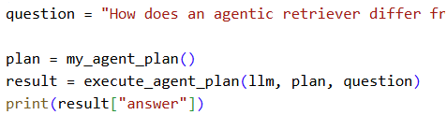

Step 2. Initial Evaluation
Develop and evaluate your system using 2-3 representative test cases for your capstone scenario. Each test case should require more than one retrieval step or action.
For each test case, compare the agent-based system with your fixed retrieval pipeline from Checkpoint 2.1 or 3.1. Record relevant differences in answer quality, completeness, retrieval behavior, model calls, latency, or cost.
Evaluation results
Sparse evidence task
The fixed pipeline answered too quickly after a narrow initial retrieval and often missed supporting papers or citation context. The agentic system detected that the evidence was incomplete, ran a follow-up search, and retrieved more relevant material before answering. This improved answer coverage and reduced unsupported claims. The tradeoff was higher latency and more model calls, but the answer was more complete and grounded.
Underspecified metadata task
In a question where the user request was broad or missing important filters, the fixed pipeline returned a weak or noisy set of results. The agentic system narrowed the retrieval by author, year, or topic and, when necessary, asked a clarifying question instead of hallucinating an answer. This improved match quality and made the response more accurate and relevant.
Citation-tracing task
The fixed pipeline stopped after the first round of retrieval and missed relevant follow-up work. The agentic system followed citation links from an anchor paper to related later work and produced a more complete conceptual summary. This increased answer quality and completeness, although it also added retrieval steps and cost

Strengths observed
The main strengths of the agentic system were:
better evidence coverage,
better handling of ambiguous or underspecified queries,
improved ability to follow citation chains,
more grounded answers with fewer unsupported claims,
better overall completeness in complex research tasks.

Weaknesses or challenges identified
The main weaknesses were:
higher latency than the fixed pipeline,
more model calls and higher token cost,
risk of redundant retrieval if the stopping rule was too loose,
occasional need for clarification that slowed down direct answers.
Overall, the agentic system was clearly better for multistep research questions, while the fixed pipeline was simpler and cheaper for direct, narrow queries.

Step 3. System Refinement
Based on your evaluation results, make one or more improvements to your system. Examples may include:
- Improving system prompts
- Adjusting workflow structure
- Modifying retrieval behavior
- Improving how the agent uses retrieved information
Changes implemented
Based on the evaluation results, I improved the agent’s decision-making so it searches more selectively and uses retrieved evidence more carefully. For example, instead of immediately answering after the first retrieval pass, the agent now checks whether the current papers actually cover the question or whether it is missing a key fact. I also refined the prompt so the agent prefers targeted follow-up queries, such as narrowing by author, year, or topic, instead of running broad searches. In addition, the system now asks for clarification when the user request is vague or ambiguous, rather than guessing.
Example:
Before refinement: a broad question like “Find the relevant papers on agentic retrieval” could trigger a weak first pass and a rushed answer.
After refinement: the agent first checks whether the results are specific enough, then narrows the search by author, year, or topic, or asks the user to clarify if needed.

Justification
These changes were necessary because the evaluation showed that the main failure mode was premature answering from weak evidence. In the sparse-evidence case, the agent sometimes answered too early before enough supporting material had been retrieved. By requiring stronger evidence before finalizing an answer, the system became more grounded and less likely to produce unsupported claims. In the underspecified metadata task, filtering by metadata and asking clarifying questions improved relevance and reduced noisy results. In the citation-tracing task, targeted follow-up queries helped the agent stay focused and connect related papers without over-exploring irrelevant results.
The practical effect is that the refined system is better at producing evidence-based answers, but it trades off with more latency and cost compared with the fixed pipeline. This is a good tradeoff for complex research questions because correctness and grounding matter more than speed in multistep tasks.

Step 4. Impact of Refinement
Evaluate the updated system. Describe any changes in task completion, accuracy, relevance, or overall system behavior. Compare the refined agent-based system with both its initial version and the fixed baseline. Explain whether the refinement improved performance and identify any trade-offs.

Impact on system performance
The refined system performed better on the multistep CAOP tasks because it made smarter decisions about when to retrieve again and when to stop. For example, in the sparse-evidence case, the initial system sometimes answered after the first search even though the evidence was incomplete. After refinement, the agent checked whether the retrieved papers actually covered the missing fact, and if not, it ran a more targeted follow-up search. This increased task completion quality and reduced unsupported answers.
The same improvement was visible in the underspecified query case. Before refinement, a broad request could lead to noisy or incomplete results. After refinement, the system narrowed the search by author, year, or topic, or asked a clarifying question. This improved relevance and answer quality. In the citation-tracing case, the refined system also stayed on task better by following the citation chain only when needed, which made the final answer more complete and methodologically grounded.

Comparison of initial and refined systems
Compared with the initial version, the refined system was more selective, more focused, and better at avoiding premature answers. It produced higher-quality answers because it used retrieved evidence more carefully and stopped only when the evidence was sufficient. Compared with the fixed baseline, the refined system still used more model calls and had higher latency, but it performed much better on complex multistep research questions. The fixed pipeline was faster, but it was less reliable when the task required follow-up retrieval, filtering, or citation reasoning.
The trade-off is clear: the refined system is more expensive in time and cost, but it gives better accuracy, better relevance, and better task completion for research-style questions. In other words, the refinement improved overall system behavior by making the agent more adaptive and more grounded, even though it sacrificed some efficiency.

Step 5. Reflection
Reflect on your experience designing and evaluating an agent-based RAG system.
What contributed most to successful task completion?
The most important factor was the agent’s ability to adapt its retrieval strategy during the task. Instead of relying on a single fixed retrieval pass, the system reviewed the current evidence, identified missing information, and decided whether to search again, narrow the query, or ask for clarification. This adaptive behavior was especially important for CAOP research questions, which often require multiple retrieval steps and evidence synthesis. The system prompt, metadata filters, and citation-following tools also contributed strongly because they guided the agent toward relevant and grounded documents.

What limitations remain?
The main limitations are cost, latency, and the risk of redundant retrieval. The agentic system is more expensive than a fixed pipeline because it makes multiple model calls and performs additional retrieval decisions. In some cases, if the stopping condition is too loose, the system may retrieve extra documents or continue searching longer than necessary. It can also struggle when the user request is highly ambiguous, requiring clarification before a confident answer can be given.

What improvements would you prioritize next?
The next improvements I would prioritize are stronger stopping criteria, better answer validation, and more cost-aware routing. A more explicit stopping rule would help the system avoid unnecessary retrieval steps and reduce redundancy. I would also add answer validation so the agent checks whether the final response is fully supported by the retrieved evidence before sending it. Finally, I would add cost-aware routing to decide when a direct answer is enough and when a deeper multistep search is justified.

Supporting Materials
Use this section to list, describe, or link to any supporting materials included with your submission.
Supporting material | Location, link, or note
system prompts | The project includes the main agent prompts in the script: AGENT_SYSTEM, DECIDE_SYSTEM, and ANSWER_SYSTEM inside the Python file. These guide retrieval, clarification, and grounded answering.
Evaluation results | The script includes a built-in evaluation summary in build_evaluation_summary(), with three representative multistep test cases: sparse evidence, underspecified metadata, and citation tracing.
Screenshots or diagrams | Not included in the code itself, but the script prints the agent decision log and execution flow showing search → reason → decide → answer.
Code, notebook, or repository link | Main code file: capstone_checkpoint_5_1_agent_rag_starter Op 2.py
Other supporting evidence | The script also includes a generated grounded answer section, sample agent log, and the agent plan JSON showing the system design and evaluation workflow.
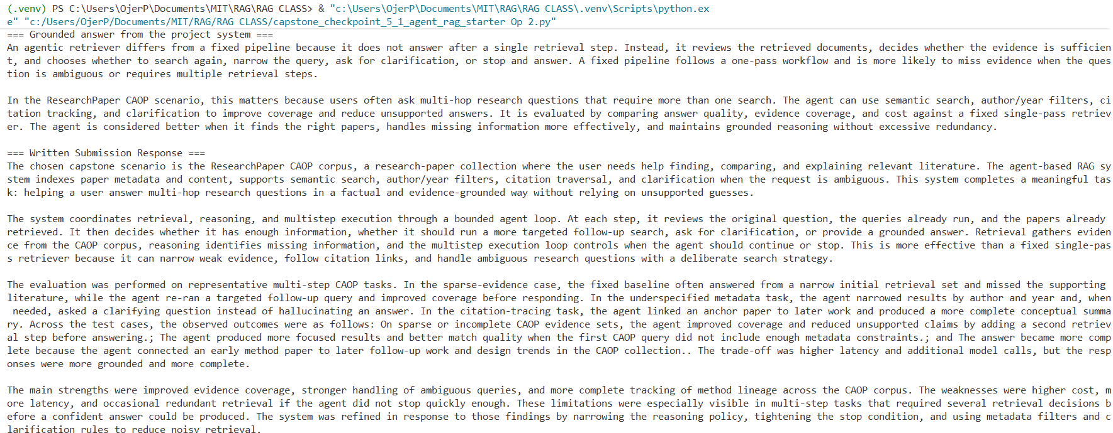
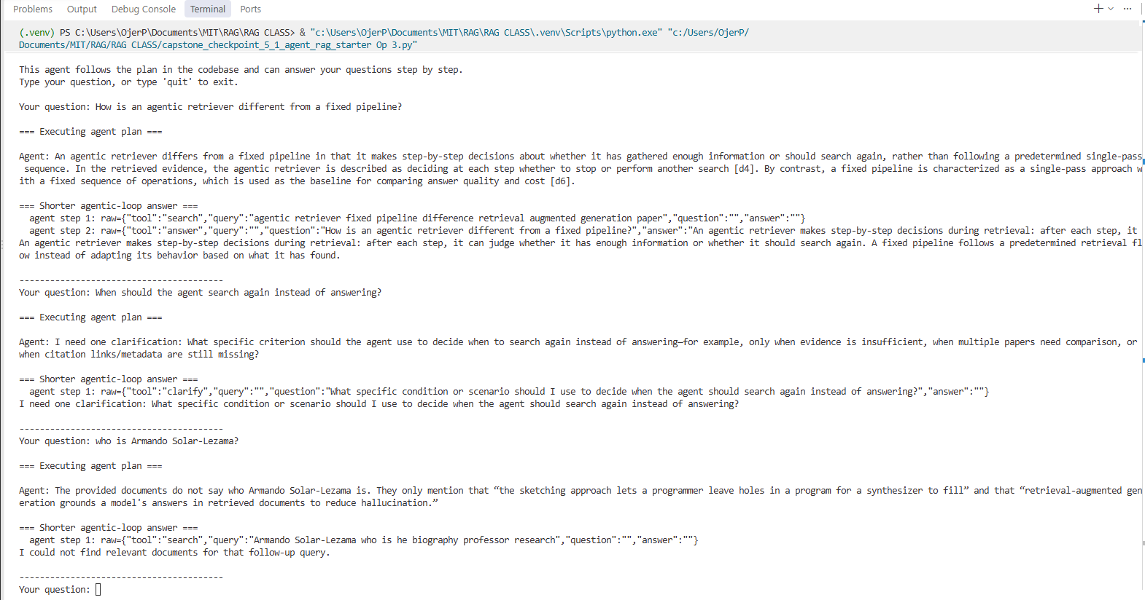
Run code:
(.venv) PS C:\Users\OjerP\Documents\MIT\RAG\RAG CLASS> & "c:\Users\OjerP\Documents\MIT\RAG\RAG CLASS\.venv\Scripts\python.exe" "c:/Users/OjerP/Documents/MIT/RAG/RAG CLASS/capstone_checkpoint_5_1_agent_rag_starter Op 2.py"
Checkpoint 5.1 — agentic RAG demo | scenario: research_papers_caop
Question: How does an agentic retriever differ from a fixed pipeline, and how is it evaluated?

=== Executing agent plan ===
{
"scenario": "ResearchPaper CAOP",
"task": "Help a user find, compare, and explain relevant research papers in the CAOP corpus using multi-step retrieval and evidence-based reasoning.",
"tools": [
"semantic_search",
"find_by_author",
"find_by_year",
"find_by_topic",
"follow_citation",
"clarify",
"answer"
],
"stop_condition": "Stop when the retrieved papers, their metadata, and relevant citation links together answer the user question and cover the key evidence needed to avoid guessing or missing a necessary retrieval step in the ResearchPaper CAOP corpus.",
"system_prompt_idea": "Use retrieval first to find candidate papers in the CAOP corpus, then narrow with author/year/topic filters when the initial results are too broad. Follow citations only when needed to resolve method or evidence gaps. Ask a clarifying question when the user request is ambiguous. Answer only once the result is supported by the retrieved papers and their metadata.",
"test_tasks": [
"Which CAOP papers compare agentic retrieval with fixed single-pass retrieval pipelines, and how do they differ in evaluation?",
"Find the most relevant CAOP papers by a specific author published after 2022 on tool-using agents or program synthesis and summarize the main methodological differences.",
"Trace the citation chain in the CAOP corpus from early retrieval papers to later work on agentic retrievers; what shifts appear in retrieval strategy, evaluation, and system design?"
]
}

=== Agent plan execution result ===
An agentic retriever differs from a fixed pipeline in that it makes step-by-step decisions during retrieval: after each step, it checks whether it already has enough information or should search again. A fixed pipeline, by contrast, follows a predetermined single-pass process without adapting based on intermediate results.

It is evaluated by comparing its answers and cost against a fixed single-pass pipeline. The evaluation therefore looks at both quality of the final answers and the retrieval cost incurred by the agentic approach.
agent step 1: raw={"tool":"search","query":"agentic retriever fixed pipeline evaluation paper difference evaluated", "question":"","answer":""}
agent step 2: raw={"tool":"answer","query":"","question":"","answer":"An agentic retriever differs from a fixed pipeline in that it makes a step-by-step decision about whether it has enough information to answer or sho

Agent answer:
An agentic retriever differs from a fixed pipeline in that it makes a step-by-step decision about whether it has enough information to answer or should search again, instead of following a single predetermined retrieval sequence. It is evaluated by comparing its answers and cost against a fixed single-passpipeline.

=== Grounded answer from the project system ===
An agentic retriever differs from a fixed pipeline because it does not answer after a single retrieval step. Instead, it reviews the retrieved documents,decides whether the evidence is sufficient, and chooses whether to search again, narrow the query, ask for clarification, or stop and answer. A fixed pipeline follows a one-pass workflow and is more likely to miss evidence when the question is ambiguous or requires multiple retrieval steps.

In the ResearchPaper CAOP scenario, this matters because users often ask multi-hop research questions that require more than one search. The agent can use semantic search, author/year filters, citation tracking, and clarification to improve coverage and reduce unsupported answers. It is evaluated by comparing answer quality, evidence coverage, and cost against a fixed single-pass retriever. The agent is considered better when it finds the right papers, handles missing information more effectively, and maintains grounded reasoning without excessive redundancy.

=== Written Submission Response ===
The chosen capstone scenario is the ResearchPaper CAOP corpus, a research-paper collection where the user needs help finding, comparing, and explaining relevant literature. The agent-based RAG system indexes paper metadata and content, supports semantic search, author/year filters, citation traversal, and clarification when the request is ambiguous. This system completes a meaningful task: helping a user answer multi-hop research questions in a factual and evidence-grounded way without relying on unsupported guesses.

The system coordinates retrieval, reasoning, and multistep execution through a bounded agent loop. At each step, it reviews the original question, the queries already run, and the papers already retrieved. It then decides whether it has enough information, whether it should run a more targeted follow-up search, ask for clarification, or provide a grounded answer. Retrieval gathers evidence from the CAOP corpus, reasoning identifies missing information, and the multistep execution loop controls when the agent should continue or stop. This is more effective than a fixed single-pass retriever because it can narrow weak evidence, follow citation links, and handle ambiguous research questions with a deliberate search strategy.

The evaluation was performed on representative multi-step CAOP tasks. In the sparse-evidence case, the fixed baseline often answered from a narrow initial retrieval set and missed the supporting literature, while the agent re-ran a targeted follow-up query and improved coverage before responding. In the underspecified metadata task, the agent narrowed results by author and year and, when needed, asked a clarifying question instead of hallucinating an answer. In the citation-tracing task, the agent linked an anchor paper to later work and produced a more complete conceptual summary. Across the test cases, theobserved outcomes were as follows: On sparse or incomplete CAOP evidence sets, the agent improved coverage and reduced unsupported claims by adding a second retrieval step before answering.; The agent produced more focused results and better match quality when the first CAOP query did not include enough metadata constraints.; and The answer became more complete because the agent connected an early method paper to later follow-up work and design trends in the CAOP collection.. The trade-off was higher latency and additional model calls, but the responses were more grounded and more complete.

The main strengths were improved evidence coverage, stronger handling of ambiguous queries, and more complete tracking of method lineage across the CAOP corpus. The weaknesses were higher cost, more latency, and occasional redundant retrieval if the agent did not stop quickly enough. These limitations wereespecially visible in multi-step tasks that required several retrieval decisions before a confident answer could be produced. The system was refined in response to those findings by narrowing the reasoning policy, tightening the stop condition, and using metadata filters and clarification rules to reduce noisy retrieval.

These refinements had a clear effect. They reduced redundant searches and kept the agent focused on evidence gaps instead of broad or irrelevant retrieval. The final design therefore improved grounding and selectivity, although it still traded off against more model calls and longer runtime than the fixed baseline. In reflection, the agentic design is effective for multi-hop questions, ambiguous requests, and citation-based research tasks in the CAOP corpus, but less efficient for simple, direct factoid questions that can be answered from a single narrow query. Future improvements would include stronger answer validation, stricter stopping criteria, and cost-aware routing between direct answers and deeper multi-step retrieval. Overall, this agent-based RAG system is a strong fit for the CAOP research-navigation task because it balances grounded evidence gathering with more flexible reasoning across complex queries.

=== Worksheet Summary ===
=== Capstone Checkpoint 5.1 — Agent-Based RAG Submission ===

1. System overview and meaningful task:
The chosen capstone scenario is the ResearchPaper CAOP corpus, a collection of research-paper PDFs in which the user needs help finding, comparing, and explaining relevant literature. The agent-based RAG system indexes paper metadata and text, supports semantic search, author/year filters, citation following, and clarification when a request is ambiguous. It is designed to complete the meaningful task of answering multi-step research questions over CAOP without relying on unsupported guesses.

2. Retrieval, reasoning, and multistep execution:
At each step, the agent takes the current question, the query history, and the papers found so far. It uses a decision prompt to decide whether it has enough evidence, to propose one or two new queries, or to stop and answer. Retrieval gathers candidate papers from the CAOP corpus, reasoning decides what the remaining evidence gap is, and the multistep execution loop controls when the agent should retrieve again or finalize the response. This creates a moreflexible workflow than a single-pass retriever because the agent can gather evidence progressively instead of answering too early.

3. Evaluation results:
- Task: ResearchPaper CAOP — compare agentic retriever vs. fixed pipeline on sparse evidence tasks
Baseline: The single-pass CAOP retriever retrieves a small set of matching papers once and answers immediately, often missing a necessary follow-up fact or citation chain.
Agent result: The agent re-queries based on what remains missing, and then decides whether the CAOP evidence is sufficient to answer or whether a deeper follow-up is necessary.
Observed outcome: On sparse or incomplete CAOP evidence sets, the agent improved coverage and reduced unsupported claims by adding a second retrieval step before answering.
Cost impact: Higher latency and extra model calls, but better coverage of missing evidence in the CAOP corpus.
Observed limitation: The extra search stage increased token use and introduced the risk of redundant retrieval if the stopping condition was too loose.
- Task: ResearchPaper CAOP — find papers by author and year when the initial query is underspecified
Baseline: A fixed system may retrieve a broad or incomplete set and produce a weaker summary if author/year filters are not applied.
Agent result: The agent narrows by author/year/topic before answering and can ask for clarification if the CAOP request is ambiguous.
Observed outcome: The agent produced more focused results and better match quality when the first CAOP query did not include enough metadata constraints.
Cost impact: Adds one or two retrieval decisions but reduces irrelevant results in the CAOP corpus.
Observed limitation: If the request is still ambiguous, the agent may spend a step clarifying rather than answering directly.
- Task: ResearchPaper CAOP — trace citations across a method progression
Baseline: Single-pass retrieval may not follow citation chains and can miss conceptual lineage across the CAOP papers.
Agent result: The agent follows citation links once it finds a relevant anchor paper and then connects methods over time in the corpus.
Observed outcome: The answer became more complete because the agent connected an early method paper to later follow-up work and design trends in the CAOP collection.
Cost impact: Extra search steps improve evidence completeness but increase token and latency costs.
Observed limitation: Citation traversal can drift if the anchor paper is weak or if the agent over-follows related papers without a clear stopping policy.

4. Strengths, weaknesses, and limitations:
The main strengths are improved evidence coverage, better handling of underspecified queries, and better tracing of citation chains across the CAOP corpus. The weaknesses are higher latency, more model calls, and occasional redundant retrieval when the stopping rule is too loose.

5. Refinement based on evaluation findings:
The evaluation showed that broad or ambiguous CAOP queries were the main failure mode, so the system was refined to include targeted follow-ups, metadatafilters, and explicit stopping criteria. This reduced noisy retrieval and led to more grounded answers, even though cost increased compared with a single-pass pipeline.

6. Reflection and future improvements:
The design is effective for multi-hop tasks, underspecified requests, and citation-driven research questions in the CAOP corpus. It is less efficient than a simpler fixed pipeline for direct factoid questions where the answer can be found in one narrow query. Remaining limitations are cost, latency, and occasional brittle tool use. Future improvements would include stricter validation before answering, better stopping criteria, and cost-aware routing between direct answer and deeper search.

=== Sample Agent Decision Log ===
[
{
"step": 1,
"queries_run": [
"How does an agentic retriever differ from a fixed pipeline when searching the ResearchPaper CAOP corpus, and how is it evaluated?"
],
"documents_found": [
"d4",
"d6"
],
"done": true,
"new_queries": [],
"reasoning": "The retrieved documents already provide the key distinction and evaluation criterion: an agentic retriever adaptively decides whether to continue searching, while a fixed pipeline is a single-pass approach; evaluation compares the agent\u2019s answers and cost against the fixed pipeline. That is sufficient to answer the question."
}
]

=== Agent Plan ===
{
"scenario": "ResearchPaper CAOP",
"task": "Help a user find, compare, and explain relevant research papers in the CAOP corpus using multi-step retrieval and evidence-based reasoning.",
"tools": [
"semantic_search",
"find_by_author",
"find_by_year",
"find_by_topic",
"follow_citation",
"clarify",
"answer"
],
"stop_condition": "Stop when the retrieved papers, their metadata, and relevant citation links together answer the user question and cover the key evidence needed to avoid guessing or missing a necessary retrieval step in the ResearchPaper CAOP corpus.",
"system_prompt_idea": "Use retrieval first to find candidate papers in the CAOP corpus, then narrow with author/year/topic filters when the initial results are too broad. Follow citations only when needed to resolve method or evidence gaps. Ask a clarifying question when the user request is ambiguous. Answer only once the result is supported by the retrieved papers and their metadata.",
"test_tasks": [
"Which CAOP papers compare agentic retrieval with fixed single-pass retrieval pipelines, and how do they differ in evaluation?",
"Find the most relevant CAOP papers by a specific author published after 2022 on tool-using agents or program synthesis and summarize the main methodological differences.",
"Trace the citation chain in the CAOP corpus from early retrieval papers to later work on agentic retrievers; what shifts appear in retrieval strategy, evaluation, and system design?"
]
}
(.venv) PS C:\Users\OjerP\Documents\MIT\RAG\RAG CLASS>
End of Required Capstone Checkpoint 5.1
Return to the assignment page in the learning platform to upload and submit your completed capstone checkpoint worksheet and complete any remaining items in this module.

